Operator Headcount Optimization
through VLSI Test Process Simulator with Human Factor
Tatsuru Matsuo ^{(a}, Koji Nakamae ^{(a}, and Hiromu Fujioka ^{(b}
a) Dept. Information Systems Engineering, Osaka University, Yamada-Oka 2-1, Suita, Osaka, 565-0871 Japan
b) Dept. Management and Information Science, Fukui University of Technology, Gakuen 3-6-1, Fukui, 910-8505 Japan

Abstract
As a result of cutthroat price competition in semiconductor manufacturing, manufacturing management problems such as human resources to improve a manufacturing efficiency and to reduce the price have received considerable attention. For example, operator headcount optimization in wafer fabrication processes have been discussed [1].
Through the event-driven simulation analysis, we have reported the effect of 300mm wafer and small lot size on the final test process efficiency and cost [2], the turnaround time (TAT) and cost reduction strategies in LSI manufacturing test process [3], and the effects of operator grouping on the final test facility layout scale in the final test process of one-chip microcomputer [4].
In this paper, we try to optimize operator headcounts in the final test process of one-chip microcomputer through the VLSI test process simulator with human factor in order to reply an employment issue how many new workers should be hired.
In the final test process, cumbersome tasks such as exchange of change kits and operation for machine troubles need a learning process. Then the function that mimics the learning curve of the human from a newly hired worker to an expert is necessary in the simulator.
We choose the following hyperbolic function with three parameter as a functional model of individual learning as shown in Fig. 1. The function is known to describe patterns of skill learning in large populations of front-line workers [5]. y is the work performance of individual after c operations (troubles) of cumulative practice. The parameters k, r and p determine the shape of improvement curves.
Two kinds of machine troubles, simple and complicated, are assumed. For complicated troubles, the newly hired worker must learn the trouble processing. The learning curve is assumed to be divided into the early, the medium, and the end stages depending on the work performance y. The learning process for each stage differs under the guidance of expert workers.
We developed an event-driven final test process simulator with the hyperbolic model of learning curve and applied it to the employment issue in the final test facility where one-chip microcomputers are tested under the nine test flows and the newly hired workers with typical learning performance are employed. The test flows include test stages such as the EPROM testing, the pre-burn-in testing, and so on. The capacity of the final test facility is about 2300 lots/month.
The simulated learning process for troubles in LSI testers is shown in Fig. 2 where the results for the five kinds of troubles A, B, C, D, and E are plotted. Figure 3 shows the relation between cost per chip and number of operators. From this result, we can see the cost optimum operator headcounts.

References
- M. Kishimoto, K. Ozawa, K. Watanabe, and D. Martin, IEEE Trans. Semiconduct. Manufact., 14, pp. 187-195. 2001.
- K. Nakamae, A. Chikamura, and H. Fujioka, Proceedings ASMC98, 1998, pp.151-155.
- H. Fujioka, K. Nakamae, A. Chikamura, and M. Kitamura, Proceedings ASMC99, 1999, pp.59-pp.63.
- K. Nakamae, W. Koga, and H. Fujioka, Proceedings ASMC2000, 2000, pp.231-236
- M.V. Uzumeri and D. A. Nembhard, J. Oper. Manage., 16, pp.515-528, 1998.

Contact Information for Corresponding Author
Name: Koji Nakamae
Section: Dept. Information Systems Eng., Grad. Sch. Information Science and Technology
Company/University: Osaka University
Address: Yamada-Oka 2-1, Suita, Osaka, Japan
Phone/Fax: +81-6-6879-7811/+81-6-6879-7812
E-mail: nakamae@ist.osaka-u.ac.jp

Key Words:
headcount optimization, human resources, final test process, simulation

AREA
Economics of LSI Testing

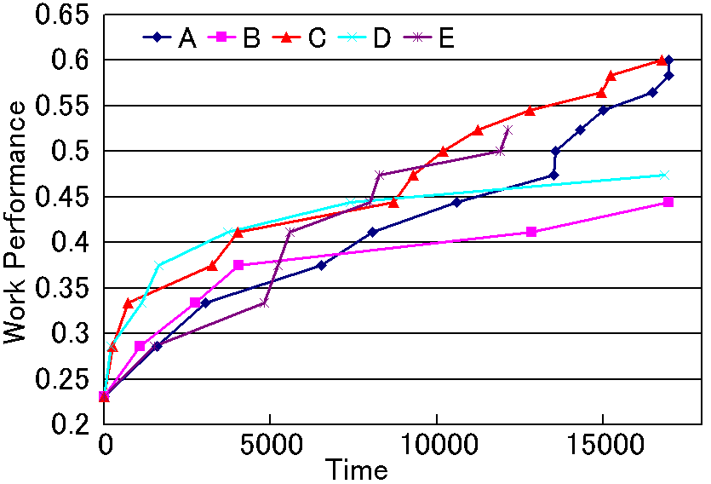
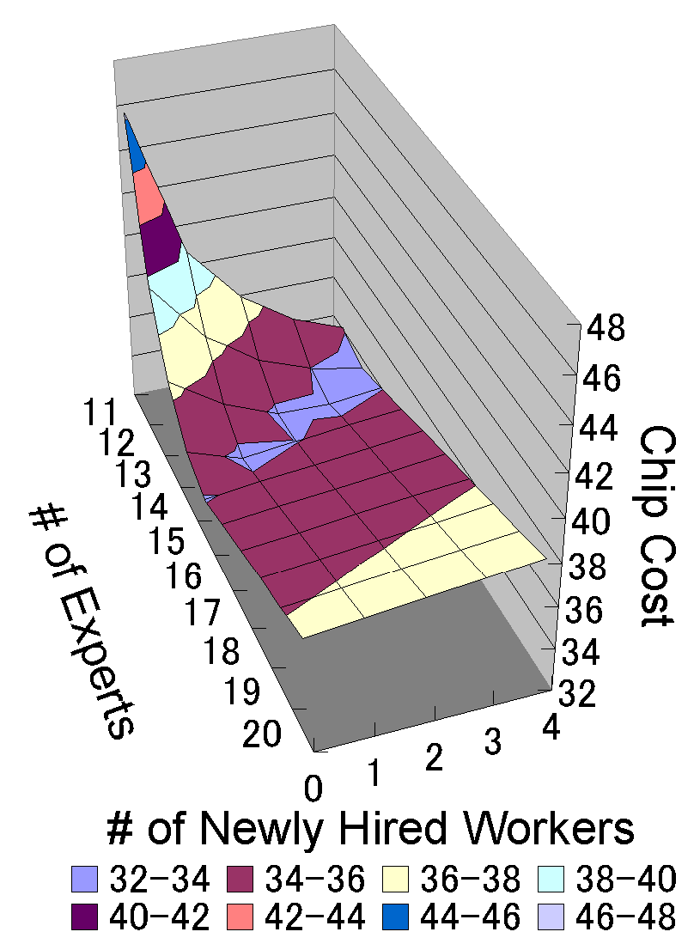
Figure 1. The 3-parameter hyperbolic model of individual learning.
Figure 2. Simulated learning process for troubles in LSI testers
Figure 3. Relation between chip cost and number of operators

